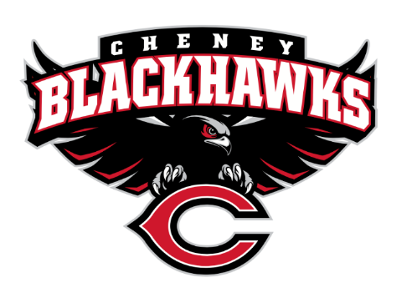
Cheney Blackhawk Booster Club
August 29, 2002
Booster Club Meeting

- Welcome & Board Intros/Krisann Hatch
  - President: Krisann Hatch
  - Vice President: Jay Evans
  - Treasurer: Mitch Swenson
  - Secretary: Kelley Hinrichs
- Review of Mission Statement/Krisann Hatch
  - The Black Booster Club’s mission is to create the “Blackhawk Home Court Advantage” that inspires students, athletes, coaches, parents and the community to collectively create a positive and spirited atmosphere for all extra-curricular and athletic programs. We are volunteers who wish to serve and lead by example. We support through fundraising, stand behind strong moral character and good sportsmanship and promote a winning school spirit by encouraging attendance at all Cheney High School activities.
- Priorities for 2022/23 School Year/Krisann Hatch
  - Establishing policies & procedures
  - Concessions’ Revenue
  - Website Adoption & Social Media Exposure
  - Establishing the role of the Parent Liaisons
  - Sponsorships
- Committee Reports
  - Concessions/Shelley Whiteley
  - Social Media/Krisann Hatch
  - Sponsorships/Dave Ittner
  - Merchandise/Jay Evans
  - Events/Open
    - Tailgates
    - Alumni Homecoming
  - Fundraising/Open
    - Silent Auction
    - Golf Tourney/Benji Estrellado
    - Mayfest Fun Run
    - Craft Fair
  - Treasurer’s Report/Mitch Swenson
- Good of the Order
  - Senior Banners
  - Future meetings – days/times

