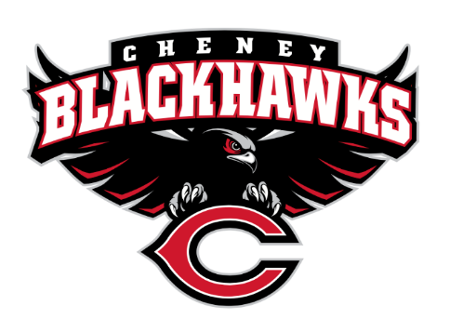
Cheney Blackhawk Booster Club
November 2, 2022
Booster Club Meeting

The Cheney Blackhawk Booster Club’s mission is to create the “Blackhawk Home Court Advantage” that inspires students, athletes, coaches, parents and the community to collectively create a positive and spirited atmosphere for all extra-curricular and athletic programs. We are volunteers who wish to serve and lead by example. We support through fundraising, stand behind strong moral character and good sportsmanship and promote a winning school spirit by encouraging attendance at all Cheney High School activities.

- Welcome & Board Intros/Krisann Hatch
  - President: Krisann Hatch
  - Vice President: Jay Evans
  - Co-Treasurers: Darcy Magalsky/Kaely Randles
  - Secretary: Kim Best
- Thank you to the following sponsors and boosters:

- Priorities Updates/Krisann Hatch
  - Establishing policies & procedures
    - Finance & Cash is a focus for the Fall
  - Concessions’ Revenue
  - Website & Social Media Exposure
  - Establishing the role of the Parent Liaisons
  - Sponsorships
- Committee Reports
  - Concessions/Shelley Whiteley
    - Fall Sports Sales
    - Winter Schedule
    - Sign-up limits
    - Wrestling Tourney and appropriate offerings
    - Concessions’ Work Day; need to confirm a date and volunteers
  - Social Media/Communications/Krisann Hatch
    - Email addresses update
  - Sponsorships/Dave Ittner
    - Memberships/Sponsorships went live on 10/11/22
    - Please – TALK IT UP!
  - Merchandise/Jay Evans
    - Fall Sports – Sales
    - CHS Staff Sales – conferences
      - 11/21 – 4pm-6pm
      - 11/22 – 8am-10am
      - Need volunteers
    - Other items? Any feedback?
    - Adam Smith Update
  - Events/Open
    - Craft Fair – 12/3/22 – need volunteers; set-up from 8am-10am; craft fair from 10am-4pm
  - Fundraising/Open
    - Golf Tourney/Benji Estrellado
  - Treasurer’s Report/Kaely Randles & Darcy Magalsky
- Good of the Order
  - Grant Request vs. Allocated Fund Requests
  - Senior Banners - $1591 for Fall sports
    - Need for a clear process, submissions, timeline, etc.
    - Winter
    - Spring
  - Insurance - update
  - Next Meeting: December 7, 2022, 6pm, CHS Commons

