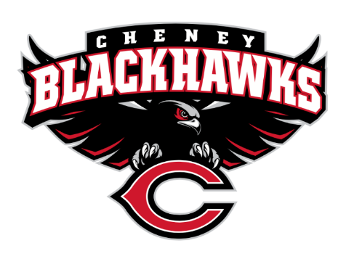
Cheney Blackhawk Booster Club
December 7, 2022
Booster Club Meeting Agenda

The Cheney Blackhawk Booster Club’s mission is to create the “Blackhawk Home Court Advantage” that inspires students, athletes, coaches, parents and the community to collectively create a positive and spirited atmosphere for all extra-curricular and athletic programs. We are volunteers who wish to serve and lead by example. We support through fundraising, stand behind strong moral character and good sportsmanship and promote a winning school spirit by encouraging attendance at all Cheney High School activities.

- Welcome & Board Intros/Krisann Hatch
  - President: Krisann Hatch
  - Vice President: Jay Evans
  - Co-Treasurers: Darcy Magalsky/Kaely Randles
  - Secretary: Kim Best
- Thank you to the following sponsors and boosters:
  - Ryan & Anne Vold, Gold Hawk Boosters
  - Krisann Hatch & James Sloan, Gold Hawk Boosters
  - Jay & Jen Evans, Hawk Boosters
  - Lynnda & Gary Evans, Hawk Boosters
- Priorities Updates/Krisann Hatch
  - Establishing policies & procedures
  - Concessions’ Revenue
  - Website & Social Media Exposure
  - Establishing the role of the Parent Liaisons
  - Sponsorships/Memberships
- Committee Reports
  - Concessions/Shelley Whiteley
    - Winter Sign-Ups
      - Need to assign a point person for each home event
    - Wrestling Tourney
      - Offerings
      - Sign-ups
    - Baseball Concessions
    - Thank you to everyone that came out and helped with the work day
    - Need to form a Concessions Committee of 4-5 people for the 2023-24 school year
  - Social Media/Communications/Krisann Hatch
  - Sponsorships/Dave Ittner
    - 4 new memberships, noted above
    - Continue to consider who you know that can be a sponsor
    - Booster Bucks
  - Merchandise/Jay Evans
    - CHS Staff Sales – $1600 in sales
    - Craft Fair Update - $2400 in sales
    - Sign-ups for all home events – NEED VOLUNTEERS!
    - Need to form a Merchandise Committee of 2-3 people
    - Other items? Any feedback?
  - Events/Open
  - Fundraising/Open
  - Treasurer’s Report/Kaely Randles & Darcy Magalsky
- Grant Requests & Allocated Funds’ Request
  - Granted: Tennis – new shed
  - Granted: Adjustable Rims for the Basketball program
  - Allocated Funds:
    - HOSA – leadership conference
- Good of the Order
  - Allocated Fund Request process and form created and on the website
  - Senior Banners Update
  - Hall of Fame idea/Coach Slaughter
  - Insurance – update
    - RV Nuccio, effective 12/6/22
  - Next Meeting: January 4, 2023, 6pm, CHS Commons

