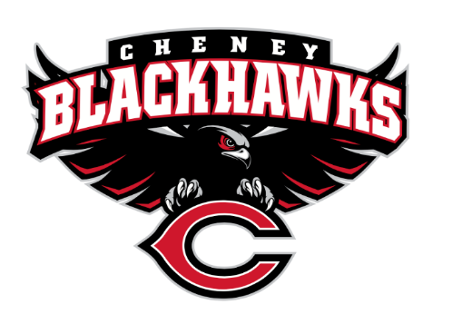
Cheney Blackhawk Booster Club
September 30, 2022
Board Meeting

The Cheney Blackhawk Booster Club’s mission is to create the “Blackhawk Home Court Advantage” that inspires students, athletes, coaches, parents and the community to collectively create a positive and spirited atmosphere for all extra-curricular and athletic programs. We are volunteers who wish to serve and lead by example. We support through fundraising, stand behind strong moral character and good sportsmanship and promote a winning school spirit by encouraging attendance at all Cheney High School activities.

- Thank you to the following sponsors:
  - Betty Hatch & Hatch Law Office for sponsoring the website
  - Hatch Law Office for providing $1500 each to both girls & boys basketball
  - Marc Hughes/Farmers Insurance for co-sponsoring Cheer
  - Tara Morton/Grace Support Services for co-sponsoring Cheer
  - Am I missing any?
- Review of October 5th Club Meeting Agenda/Krisann
- Priorities Updates/Krisann
  - Establishing policies & procedures
  - Concessions’ Revenue
  - Website Adoption & Social Media Exposure
  - Establishing the role of the Parent Liaisons
  - Sponsorships
- Committee Reports
  - Concessions/Shelley
    - Battle in the 509/Krisann
  - Social Media/Krisann
    - Email address update/Concessions’ Email
  - Sponsorships/Dave
    - Jordan Family Farm/Erin & Ross Jordan
  - Merchandise/Jay
    - Next order?
    - Additional items?
    - Sell merchandise at vball games?
    - Adam Smith
    - Volunteers for October 14th game
  - Events/Open – need someone to take this on
    - Tailgates
  - Fundraising/Open
    - Do we want to consider a winter/spring fundraiser?
  - Treasurer’s Report/Mitch
    - Tracking and allocating funds
      - $200 concessions’ allocations
      - Sponsorships (website, others)
    - General Fund
    - Merchant Services Update
    - Use of Venmo?
    - Should we be able to purchase items tax-free?
    - Replacing Mitch
- Good of the Order
  - Kim Best – has volunteered to be the next Secretary; Motion Required
  - Darcy Magalsky & Kaylie Randles have volunteered to be the next Treasurer; Motion required
  - Senior All-Nighter request/Barb Flock
  - Senior Banners – Update
    - $1400 for Fall sports; sponsor? Or CBBC?
  - Next Board Meeting: October 28, 2022
  - Next Booster Meeting: October 5, 2022 @ 6pm in the CHS Commons

