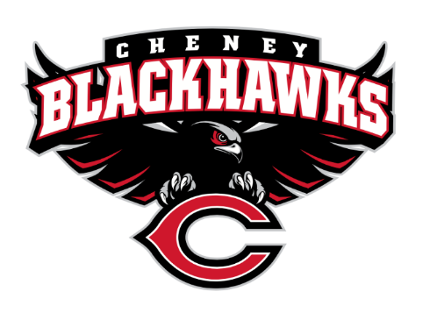
Cheney Blackhawk Booster Club
April 10, 2023
Booster Club Meeting Agenda

The Cheney Blackhawk Booster Club’s mission is to create the “Blackhawk Home Court Advantage” that inspires students, athletes, coaches, parents and the community to collectively create a positive and spirited atmosphere for all extra-curricular and athletic programs. We are volunteers who wish to serve and lead by example. We support through fundraising, stand behind strong moral character and good sportsmanship and promote a winning school spirit by encouraging attendance at all Cheney High School activities.

- Welcome & Board Intros/Krisann Hatch
  - President: Krisann Hatch
  - Vice President: Jay Evans
  - Co-Treasurers: Darcy Magalsky/Kaely Randles
  - Secretary: Kim Best
- Thank you to the following sponsors and boosters:
- 2023/24 Priorities Updates/Krisann Hatch
  - Memberships
  - Sponsorships
  - Establishing our Events Calendar
  - Eliminate the need for teams to seek individual sponsorships - $50,000 goal
- Committee Reports
  - Concessions/Shelley Whiteley
    - Spring Update
  - Social Media/Communications/Krisann Hatch
  - Sponsorships/Jay Evans & Kelly Collins
    - Update
  - Memberships/Krisann
    - Membership Drive/Action Plan
    - Attending the Incoming Freshman event at CHS on April 25th
  - Merchandise/Jay Evans & Teresa McCorkel
    - Ordering golf items for tourney
    - Upcoming events:
      - April 25th – Incoming Freshman event
      - April 28th – Lunch Spirit Gear sales at CHS
      - May 13th – Mayfest
      - May 21st – Golf Tourney
  - Events/Krisann
    - January: Blackhawk Wrestling Invite
    - February (2024): Annual Bowl-A-Thon
    - April: VanKuren Track Invite – April 15th
    - May:
      - Mayfest May 12-13th
      - Golf Tourney – May 21st
    - June: All-Sport Recognition Night – June 5th
    - July: Rodeo
    - August: All-Sport BBQ Kick-off/Mary Shay Soccer Tournament
    - September/October: Homecoming
    - October: Battle in the 509 Cross Country Track Meet
    - Turkey Trot
    - Craft Fair
  - Treasurer’s Report/Kaely Randles & Darcy Magalsky
- Grant Requests & Allocated Funds’ Request
  - Grants Approved:
    - Football: Uniforms - $12,900; decision TBD
    - Track: Food for the VanKuren Invite Hospitality Suite - $1000-1500; APPROVED
    - Baseball; Laser levelling of the infield plus surface field conditioner; $2,000 plus tax; APPROVED
  - Allocations:
    - Tennis; bowling; requested $70
- Good of the Order
  - Next Meeting: May 1, 2023, 6pm, CHS Commons

