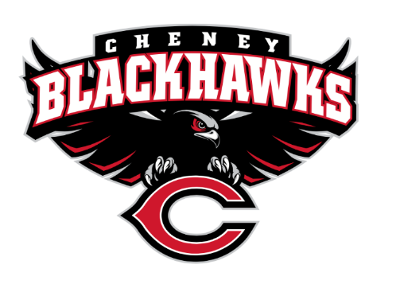
Cheney Blackhawk Booster Club
April 10, 2023
Booster Club Meeting MINUTES

The Cheney Blackhawk Booster Club’s mission is to create the “Blackhawk Home Court Advantage” that inspires students, athletes, coaches, parents and the community to collectively create a positive and spirited atmosphere for all extra-curricular and athletic programs. We are volunteers who wish to serve and lead by example. We support through fundraising, stand behind strong moral character and good sportsmanship and promote a winning school spirit by encouraging attendance at all Cheney High School activities.

- Welcome & Board Intros/Krisann Hatch
  - President: Krisann Hatch
  - Vice President: Jay Evans (absent)
  - Co-Treasurers: Darcy Magalsky/Kaely Randles
  - Secretary: Kim Best (absent)
- Thank you to the following sponsors and boosters:
- 2023/24 Priorities Updates/Krisann Hatch
  - Memberships
  - Sponsorships
  - Establishing our Events Calendar
  - Eliminate the need for teams to seek individual sponsorships - $50,000 goal
- Committee Reports
  - Concessions/Shelley Whiteley
    - Spring Update; going well, albeit very slow; weather isn’t helping
    - Still need volunteers for the VK Invite this weekend – please consider!
    - Need to update the website with the Spring Concessions link; Krisann to handle; DONE
  - Social Media/Communications/Krisann Hatch
    - No updates; just special thanks to Kim Best for all her work and creativity on our postings!
  - Sponsorships/Jay Evans & Kelly Collins
    - Update; Jay, Kelly and Krisann met on 3/27 to develop a plan and review the list of past & current sponsors; just waiting on the brochure then will assign accounts and get moving!
  - Memberships/Krisann & Kim Cunningham
    - Membership Drive/Action Plan; Kim & Krisann to meet and review the task list; have numerous events coming up to solicit memberships (see below)
    - Attending the Incoming Freshman event at CHS on April 25th; speaking and setting up Spirit Gear sales
  - Merchandise/Jay Evans & Teresa McCorkel
    - Ordering golf items for tourney
    - Upcoming events:
      - April 25th – Incoming Freshman event
      - April 28th – Lunch Spirit Gear sales at CHS
      - May 13th – Mayfest
      - May 21st – Golf Tourney
  - Events/Krisann
    - January: Blackhawk Wrestling Invite
    - February (2024): Annual Bowl-A-Thon
    - April: VanKuren Track Invite – April 15th
    - May:
      - Mayfest May 13th
      - Golf Tourney – May 21st
        - 9am shotgun start; scramble format; 11 holes; doing really well on filling openings and sponsorships; would love some help with silent auction items; CBBC to provide a gift basket with spirit gear; Krisann
    - June: All-Sport Recognition Night – June 5th
    - July: Rodeo
    - August: All-Activity BBQ Kick-off
      - Mary Shay Soccer Tournament – 8/30
    - September/October: Homecoming
    - October: Battle in the 509 Cross Country Track Meet
    - Turkey Trot
    - Craft Fair
  - Treasurer’s Report/Kaely Randles & Darcy Magalsky
    - Account balance = $28353.22; $3075 in outstanding checks and $8030 in allocated accounts
- Grant Requests & Allocated Funds’ Request
  - Grants Requested:
    - Football: Uniforms - $12,900; decision TBD
    - Track: Food for the VanKuren Invite Hospitality Suite - $1000-1500; APPROVED
    - Baseball; Laser levelling of the infield plus surface field conditioner; $2,000 plus tax; APPROVED
  - Allocations:
    - Tennis; bowling; requested $70; spent $129
- Good of the Order
  - Senior banners are done! About 57 seniors in spring activities
  - Next Meeting: May 1, 2023, 6pm, CHS Commons

