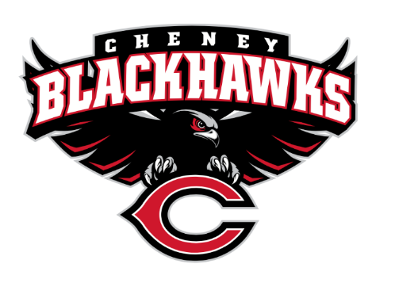
Cheney Blackhawk Booster Club
September 6, 2023
Booster Club Meeting Agenda

The Cheney Blackhawk Booster Club’s mission is to create the “Blackhawk Home Court Advantage” that inspires students, athletes, coaches, parents and the community to collectively create a positive and spirited atmosphere for all extra-curricular and athletic programs. We are volunteers who wish to serve and lead by example. We support through fundraising, stand behind strong moral character and good sportsmanship and promote a winning school spirit by encouraging attendance at all Cheney High School activities.

- Welcome & Board Intros/Krisann Hatch
  - President: Krisann Hatch
  - Vice President: Jay Evans
  - Co-Treasurers: Darcy Magalsky/Kaely Randles
  - Secretary: Kim Best
- Thank you to all of our sponsors and boosters!
- 2023/24 Priorities Updates/Krisann Hatch
  - Memberships
  - Sponsorships
  - Revenue Generation through Concessions & Spirit Gear Sales
  - Establishing our Events Calendar
- Committee Reports
  - Concessions/Erin Luttermoser & Amanda Godsil
    - Fall Update?
    - Outstanding sign-up needs?
  - Social Media/Communications/Krisann Hatch & Kim Best
  - Sponsorships/Jay Evans & Kelly Collins
    - Update
  - Memberships/Krisann Hatch & Kim Cunningham
    - Membership Drive/Action Plan
  - Merchandise/Jay Evans & Teresa McCorkel
    - Fall Update?
    - Outstanding sign-up needs?
  - Events/Krisann
    - January: Blackhawk Wrestling Invite
    - February (2024): Annual Bowl-A-Thon
    - April: VanKuren Track Invite
    - May:
      - Mayfest
      - Golf Tourney
    - June: All-Sport Recognition Night
    - July: Rodeo
    - August:
      - All-Sport BBQ Kick-off
      - Mary Shay Soccer Tournament
    - September:
      - Sept 23rd – Band Community Day
      - Sept 30th – Battle in the 509 Cross Country Track
    - October: Homecoming
    - November: Turkey Trot
    - Craft Fair
  - Treasurer’s Report/Kaely Randles & Darcy Magalsky
- Grant Requests
  - Girls’ Soccer - $1325.90
- Good of the Order
  - Next Meeting: October 4, 2023, 6pm, CHS Commons

Sponsors:
Heritage Funeral & Cremation – Gold Sponsor
Northern Quest Casino – Silver Sponsor
Lydig Construction – Silver Sponsor
Rosa’s Pizza – Silver Sponsor
CHAS Health – Bronze Sponsor
Jewelry Design Center – Bronze Sponsor
Hatch Law Office – Bronze Sponsor

Members:
Curt & Lisa Griffin – Blackhawk Booster
Betty Hatch – Blackhawk Booster
Casey & Nikki Kinzer – Blackhawk Booster
Ray & Amy Scmitt – Blackhawk Booster
Krisann Hatch & James Sloan – Blackhawk Booster
The Boerger Family – Blackhawk Booster
Ken & Shelby Ryan – Gold Hawk Booster
SixJ Farms/Jordan Family – Gold Hawk Booster
Gary & Lynnda Evans – Silver Hawk Booster
The Miller Family – Silver Hawk Booster
The Marini Family – Silver Hawk Booster
Tim & Ginger Kennedy – Silver Hawk Booster
Travis Peevey & Jenna Hatch – Silver Hawk Booster
Brett & Greta Hale – Silver Hawk Booster
Jay & Jen Evans – Silver Hawk Booster
The Stinson Family – Silver Hawk Booster
The Magalsky Family – Silver Hawk Booster
The McCorkel Family – Bronze Hawk Booster
The Bowman Family – Hawk Booster

