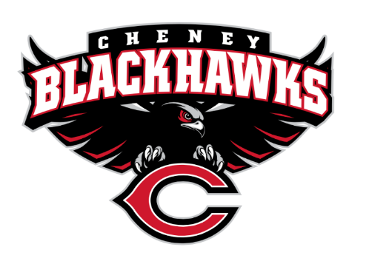
Cheney Blackhawk Booster Club
October 4, 2023
Booster Club Meeting Agenda

The Cheney Blackhawk Booster Club’s mission is to create the “Blackhawk Home Court Advantage” that inspires students, athletes, coaches, parents and the community to collectively create a positive and spirited atmosphere for all extra-curricular and athletic programs. We are volunteers who wish to serve and lead by example. We support through fundraising, stand behind strong moral character and good sportsmanship and promote a winning school spirit by encouraging attendance at all Cheney High School activities.

Thank you to everyone that volunteered for the Battle in the 509 XC Track Meet!!

- Welcome & Board Intros/Krisann Hatch
  - President: Krisann Hatch
  - Vice President: Jay Evans
  - Co-Treasurers: Darcy Magalsky/Kaely Randles
  - Secretary: Kim Best
- Thank you to all of our sponsors and boosters!
  - 12 Sponsors
  - 27 Members
- 2023/24 Priorities Updates/Krisann Hatch
  - Memberships
  - Sponsorships
  - Revenue Generation through Concessions & Spirit Gear Sales
  - Establishing our Events Calendar
- Committee Reports
  - Concessions/Erin Luttermoser & Amanda Godsil
    - Fall Update?
    - Outstanding sign-up needs?
  - Social Media/Communications/Krisann Hatch & Kim Best
  - Sponsorships/Jay Evans & Kelly Collins
    - Update
    - 12 sponsors
    - Several in the works – OK Electric, Air Force, J&M Fabrication, Maverik, Owl Pharmacy, Cottonwood Creek
    - Waiting on the exclusive sponsor decal from NBS Promos
  - Memberships/Krisann Hatch & Kim Cunningham
    - Fall Update
    - 27 members AND COUNTING!
    - Stadium seats on back-order
    - Board is considering a $25 CHS Staff Membership; would provide a 50% off coupon for one Spirit Gear item
  - Merchandise/Teresa McCorkel & Cassie Blean
    - Fall Update?
    - Outstanding sign-up needs?
    - Adding some new items and prepping for Craft Fair
      - Stanley dupe tumbler
      - Joggers

  - Events/Krisann
    - January: Blackhawk Wrestling Invite
    - February (2024): Annual Bowl-A-Thon; confirming a date and will be looking to form a committee
    - April: VanKuren Track Invite
    - May:
      - Mayfest
      - Golf Tourney
    - June: All-Sport Recognition Night
    - July: Rodeo
    - August:
      - All-Sport BBQ Kick-off
      - Mary Shay Soccer Tournament
    - September:
      - Sept 23rd – Band Community Day – VERY SUCCESSFUL!
      - Sept 30th – Battle in the 509 Cross Country Track
    - October: Homecoming
    - November: Turkey Trot
    - Craft Fair
  - Treasurer’s Report/Kaely Randles & Darcy Magalsky
- Grant Requests
  - Girls’ Soccer - $1325.90
  - Basketball – new rims - $1500
- Good of the Order
  - Ken Ryan:
    - Hall of Fame
    - Media Day
    - Fall & Spring Cleaning Events
    - Other?
  - Senior Banners’ update
  - Next Meeting: November 1, 2023, 6pm, CHS Commons

