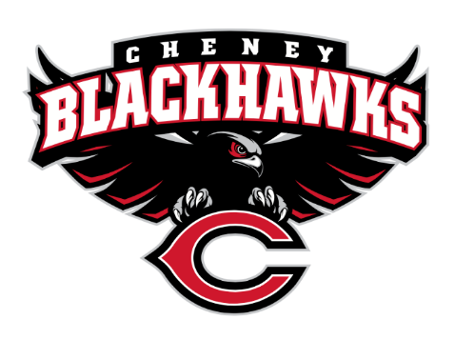
Cheney Blackhawk Booster Club
December 6, 2023
Booster Club Meeting Agenda

The Cheney Blackhawk Booster Club’s mission is to create the “Blackhawk Home Court Advantage” that inspires students, athletes, coaches, parents and the community to collectively create a positive and spirited atmosphere for all extra-curricular and athletic programs. We are volunteers who wish to serve and lead by example. We support through fundraising, stand behind strong moral character and good sportsmanship and promote a winning school spirit by encouraging attendance at all Cheney High School activities.

- Welcome & Board Intros/Krisann Hatch
  - President: Krisann Hatch
  - Vice President: Jay Evans
  - Co-Treasurers: Darcy Magalsky/Kaely Randles
  - Secretary: Kim Best
- Thank you to all of our sponsors and boosters!
  - 11 Sponsors, plus PowerAd sponsors
  - 34 Members
- 2023/24 Priorities Updates/Krisann Hatch
  - Memberships
  - Sponsorships
  - Revenue Generation through Concessions & Spirit Gear Sales
  - Establishing our Events Calendar
- Committee Reports
  - Concessions/Erin Luttermoser & Amanda Godsil
    - Winter Update
      - Band event on January 27th
  - Social Media/Communications/Kim Best
  - Sponsorships/OPEN
    - Update
  - Memberships/Jenny Gasperino
    - Winter Update
    - 34 members AND COUNTING!
    - Sign up after Jan 1 and get 6 months free – through June 2025
  - Merchandise/Teresa McCorkel & Cassie Bleam
    - Winter Update
  - Events/Krisann
    - January: Blackhawk Wrestling Invite – January 6th
    - March – Spring Sports’ Media Day -
    - April: VanKuren Track Invite
    - May:
      - Mayfest
      - Golf Tourney
    - June: All-Sport Recognition Night
    - July: Rodeo
    - August:
      - All-Sport BBQ Kick-off
      - Mary Shay Soccer Tournament
    - September:
      - Band Community Day
      - Battle in the 509 Cross Country Track
    - October: Homecoming
    - November: Turkey Trot – November 23rd
    - Craft Fair – December 2nd
  - Treasurer’s Report/Kaely Randles & Darcy Magalsky
- Grant Requests
  - Winter Sports Social Media Day; $1800; photography, videography, etc.; APPROVED
  - Wrestling; singlets; $326 (using $1200+ from allocated funds, too); APPROVED
  - Girls Bball; travel cost for Wenatchee tourney; $451.52; APPROVED
- Good of the Order
  - Ken Ryan:
  - Next Meeting: January 3, 2024, 6pm, CHS Commons

