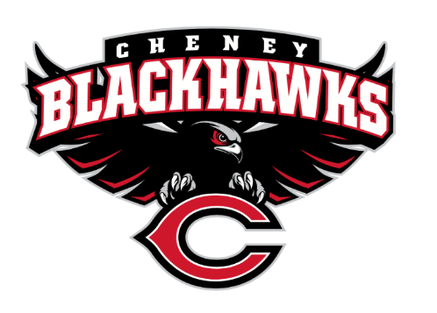
The Cheney Blackhawk Booster Club’s mission is to create the “Blackhawk Home Court Advantage” that inspires students, athletes, coaches, parents and the community to collectively create a positive and spirited atmosphere for all extra-curricular and athletic programs. We are volunteers who wish to serve and lead by example. We support through fundraising, stand behind strong moral character and good sportsmanship and promote a winning school spirit by encouraging attendance at all Cheney High School activities.

Cheney Blackhawk Booster Club Meeting Agenda
Date: February 4, 2026
Time: 6pm
Location: CHS Library
Special Guest Presentation: Horse Bowl Competitors Grant requested a few months back, Presented back in Nov at a Board meeting. Members present to present on their competition. Jason Dodge in 4-H junior, 4 yrs, Anika Warren 4-H for 7yrs, team of 5. Horses bowl jeopardy style competition in Kentucky. Followed by touring nearby facilities. Amazing trip learned lots, gained knowledge for further internships in future jobs.
I. Call to Order
- Welcome! Started @ 605pm/620pm
- Executive Board Introductions:
  - Krisann Hatch, President present
  - Ray Schmitt, Vice President present
  - Darcy Magalsky, Co-Treasurer present
  - Kaely Randles, Co-Treasurer present
  - Teresa McCorkel, Secretary present
II. Treasurer's Report
- Financial report As of Nov $112,142.20, $ 85,986.06 allocated 5,000 track grant, $21 246.14 left
- Recent grant requests: Darcy reported on this
  - Chess Team State Tournament; $1300, includes van, gas, hotels, reg fee for 4 competitors; contingent upon team making state; $400 in allocated fund to be applied; APPROVED
- Questions or comments?
IV. Committee Reports
- Golf Scramble Committee – Ken Ryan (absent)/John Graham reported 26 June 26, at the Plains, 11-hole event entry fee $100 down from last year $125, option of 4- or 5-man team, Ken working on the flyer, passed around flyer to look at. QR code not working, working on the logistics, looking for more people for the committee. Great deal from the Plains. Athletes will be helping, not as many games at the holes. Silent auction and raffle items to make up for not having money at the holes. Question asked-has it always been on a Friday? Other courses have no availability on the weekends only available during the week.
- Membership Committee – Jenny Gasperino not present
  - 44 members, as of 2/3/26
- Sponsorship Committee – Nick Fell not present
  - New sponsors:
    - Working on Basin Feed
    - Also supporting Adopt-a-Hurdle and Golf Scramble individuals or sponsors can donate and get a name on the hurdle to raise money for new hurdles a new set is 2,500.
- Spirit Gear Committee – Cassie Lustri present
  - Winter update hosting Spring Yard sale to get inventory out to Spring sports in late March and then transition gear over to DECCA. Gear will be at the Golf Scramble discounts to help clear out inventory. DECCA will be taking over gear sales during the day and be at key events. Smaller box of merchandise a traveling box of spirit gear during spring events. Question asked-can we use existing coupons online? No
- Concessions Committee – Sheri Jenkins present
  - Winter Update finished up regular winter events holding for Basketball for any more events 1st round state B in the next couple of events for spring sign up, not as many and smaller, CBBC will be mostly manning. Biggest one Van Kuren. On the website under volunteer can fill in email to get on the email list. For next year looking for more committee members. Thanks to Ray fixing the sink.
  - Discuss upcoming events:
V. Old Business
- Board Opportunities – n/a; all positions filled Krisann reported

VI. New Business
- 2026 Golf Scramble – June 26, 2026 @ 1pm at The Plains
- Ken’s Korner: not present, reported by John G, Ken at district Tennis for GSL Cheer at state at Battle Ground, boys and girls wrestling at the convention center for district 6, Girls GSL champions, swim and dive in Walla Walla boys and girls last game at Shadle Friday Spring sports start March 2, 2026.
VII. Announcements
- Announcements and Upcoming Events: FBLA, Skills USA, going Cashless at the door for events? Push communication on it to patrons. Orchestra this weekend skills clinic focusing on Elementary 30-35 registered, leadership opportunity.
  - Hall of Fame – nominations needed! one this year from last year that could not make it. Form needs to be filled out rather than verbal, share spread the word. Recent graduate and graduated for at least 7 yrs nominated on by the CBBC board in June.
VIII. Open Forum
IX. Adjournment
- Next Booster Club meeting on Wednesday, March 4, 2026 at 6pm in the CHS Library
Meeting adjourned @ 655pm

Members in Attendance
Emalee C
Cassi L
Ginger K
John Graham
Sheri J
Kim C
Kaely R
Dacrey M
Ray S
Barb F
Gretchen
Amanda G
Erin M

