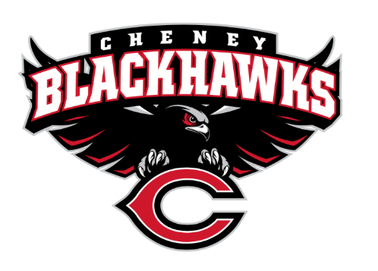
The Cheney Blackhawk Booster Club’s mission is to create the “Blackhawk Home Court Advantage” that inspires students, athletes, coaches, parents and the community to collectively create a positive and spirited atmosphere for all extra-curricular and athletic programs. We are volunteers who wish to serve and lead by example. We support through fundraising, stand behind strong moral character and good sportsmanship and promote a winning school spirit by encouraging attendance at all Cheney High School activities.

Cheney Blackhawk Booster Club Meeting Agenda
Date: April 1, 2026
Time: 6pm Meeting started at 607pm
Location: CHS Library
I. Call to Order
- Welcome!
- Executive Board Introductions:
  - Krisann Hatch, President present
  - Ray Schmitt, Vice President present
  - Darcy Magalsky, Co-Treasurer absent
  - Kaely Randles, Co-Treasurer absent
  - Teresa McCorkel, Secretary present
II. Treasurer's Report
- Financial report $123,216,80 total, $83,000 allocated, $5,000 complete set of hurdles and cart, $10,000 operating costs, $25, 440 available for grants. Decrease in grant request, using other available funds first.
- Recent grant requests:
- Questions or comments?
IV. Committee Reports
- Golf Scramble Committee – Ken Ryan present/John Graham absent
- Membership Committee – Jenny Gasperino absent
  - No new members current members are getting emails for renewals, will by trying to get more information out to freshman parents
  - Renewal emails sent
- Sponsorship Committee – Nick Fell present
  - Activity Update: working on new sponsorships; Basin Feed, Western Farms of WA, working on renewal emails
  - New sponsors:
- Spirit Gear Committee – Cassie Lustri absent
  - Winter/Spring update merchandise also available online with Performance Imprint
Turning the gear over to DECCA, summer slimming down inventory
QUESTION: any details on the garage sale?
    - Will be at Freshman Night on April 28th
    - Holding a garage sale on April 25th to clear inventory
    - DECA will be taking over Spirit Gear for the 26/27 school year
- Concessions Committee – Sheri Jenkins absent will be continuing for next year
  - Winter/Spring Update no soccer concessions or baseball
  - Discuss upcoming events: spring sports have started, events are filled
Big events; Special Olympics, GSL Championship and VAN Kuren
Pro Start asked to sale freeze dried fruits; 2 sizes 2 prices, small $2.25 sale for $4.25, big $5.00 sale for $8.00
V. Old & New Business
- Hall of Fame Nominations
  - Clarence Martin
  - Dr. Bart Harmon
- Board nominations
  - Anne Vold, Board President as of 7/1/26
- Freshman Parent Night, April 28, 2026
- Ken’s Korner: present Hosted State B Basketball
  - Golf Scramble flyer is out, meal/lunch, golf then awards, athletic programs come up with a sponsor of $500 and try for 5-person team
Wing of Excellence still working on, also score boards for softball and baseball fields
QUESTION: Football for Fall at CHS?
Adams Family Play-7,8,9,14,15,16 of May, elementary free 1pm of the 16th, lowered prices $5 students and $10 adults
Summer weights online, invited for the 3rd session Middle School for $75, 9th-12th $100 29 June-Aug, Youth Camps dates thru July all out before summer for parent planning.
Softball team new uniforms, rotation of uniforms working on 2nd rotation, band every 8 years-$80-90k
On the right track, student athletes are doing great things
45 WIAA Choir and Orchestra
Proud of the Booster Club Board and Members

VI. Announcements
- Announcements and Upcoming Events:
VII. Open Forum
QUESTION: hurdle drive $5,000 from the CBBC goal close to $9-10,000, hurdles have possibly been ordered
Brand new printer for the production of Senior Banners
Newsletter ideas for Mr.Hale
Large group Festival with Orchestra last week at CHS
Feelers out for potential treasures-approximately 1-10 hours a week
VIII. Adjournment @715
- Next Booster Club meeting on Wednesday, May 6, 2026 at 6pm in the CHS Library

In Attendance
Krisann
Ray
Nick
Kim C
Amanda G
Ann V
Sheri
Teresa

