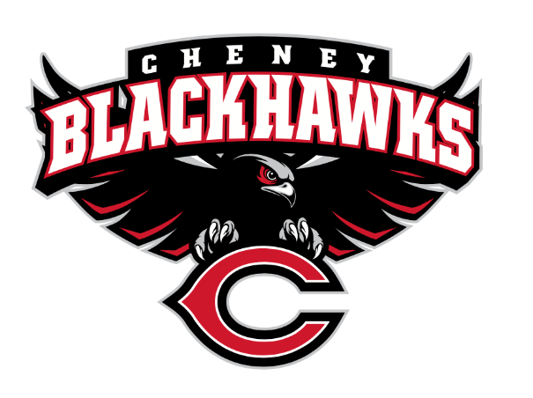

The Cheney Blackhawk Booster Club’s mission is to create the “Blackhawk Home Court Advantage” that inspires students, athletes, coaches, parents, and the community to collectively create a positive and spirited atmosphere for all extra-curricular and athletic programs. We are volunteers who wish to serve and lead by example. We support through fundraising, stand behind strong moral character and good sportsmanship, and promote a winning school spirit by encouraging attendance at all Cheney High School activities.

Cheney Blackhawk Booster Club Meeting Agenda
Date: September 2, 2026
Time: 6:00 pm
Locations: CHS Library

- Call to Order
- Welcome and Happy New School Year!
- Executive Board Introductions:
  - Anne Vold – President
  - Ray Schmitt – Vice President
  - Teresa McCorkel – Secretary
  - Jake Morrison – Treasurer

- Treasurer’s Report
- Financial report
- Recent grant requests
- 2026-2027 Budget
- Questions or comments?

- Committee Reports
- Spirit Gear
- Sponsorship – Nick Fell
- Concessions – Sheri Jenkins
- Social Media – Casie Lustri
- Membership – Jenny Gasperino

Booster Momentum - Current momentum and how we build on it

- Old Business
- Golf Scramble

- New Business
- Upcoming Events
- 9/18 Football Give Away – Rally Towels
- 9/25 Hall of Fame
- Ken’s Corner

- Open Forum

- Adjournment

Next Booster Club meeting on Wednesday October 7th, 2026 at 6pm in the CHS Library

