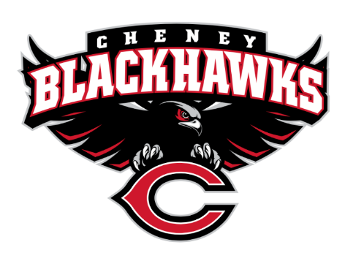
Cheney Blackhawk Booster Club
October 5, 2022
Booster Club Meeting

The Cheney Blackhawk Booster Club’s mission is to create the “Blackhawk Home Court Advantage” that inspires students, athletes, coaches, parents and the community to collectively create a positive and spirited atmosphere for all extra-curricular and athletic programs. We are volunteers who wish to serve and lead by example. We support through fundraising, stand behind strong moral character and good sportsmanship and promote a winning school spirit by encouraging attendance at all Cheney High School activities.

- Welcome & Board Intros/Krisann Hatch
  - President: Krisann Hatch
  - Vice President: Jay Evans
  - Treasurer: Mitch Swenson
  - Secretary: Kelley Hinrichs
- Thank you to the following sponsors and boosters:
  - Betty Hatch & Hatch Law Office for sponsoring the website
  - Hatch Law Office for providing $1500 each to both girls & boys basketball
  - Marc Hughes/Farmers Insurance for co-sponsoring Cheer
  - Tara Morton/Grace Support Services for co-sponsoring Cheer
  - Gary Kasparek/NWFCS Match
- Priorities Updates/Krisann Hatch
  - Establishing policies & procedures
  - Concessions’ Revenue
  - Website Adoption & Social Media Exposure
  - Establishing the role of the Parent Liaisons
  - Sponsorships
- Committee Reports
  - Concessions/Shelley Whiteley
    - Update – September/Battle for the 509
    - Clarification on what “signing up” means for getting your $200 credit
    - $400 for football concessions
  - Social Media/Krisann Hatch
  - Sponsorships/Dave Ittner
    - Update – about to go live!
    - Modifications to Memberships/Sponsorships
    - Please – TALK IT UP!
  - Merchandise/Jay Evans
    - Decent sales on 9/23; lots of suggestions
    - Placed another order for 10/14 home football game
    - Purchasing additional items – lanyards, decals, stickers
    - Need volunteers for 10/14 home football game
  - Events/Open
    - Tailgates – 10/14?
  - Fundraising/Open
    - Golf Tourney/Benji Estrellado
  - Treasurer’s Report/Mitch Swenson
- Good of the Order
  - Senior Banners - $1400 for Fall sports
  - Role of the parent liaison
  - Gym Hallway; CHS/CBBC partner to do something – ideas?
  - Insurance – obtaining quotes
  - New Board Members
    - Kim Best, Secretary
    - Darcy Magalsky & Kaely Randles, Co-Treasurers
    - THANK YOU to Kelley Hinrichs & Mitch Swenson
  - Next Meeting: November 2, 2022, 6pm, CHS Commons

