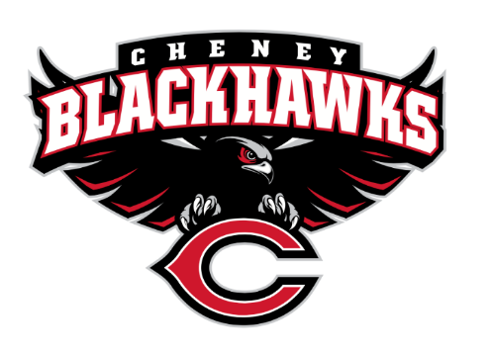
Cheney Blackhawk Booster Club
January 4, 2023
Booster Club Meeting Agenda

The Cheney Blackhawk Booster Club’s mission is to create the “Blackhawk Home Court Advantage” that inspires students, athletes, coaches, parents and the community to collectively create a positive and spirited atmosphere for all extra-curricular and athletic programs. We are volunteers who wish to serve and lead by example. We support through fundraising, stand behind strong moral character and good sportsmanship and promote a winning school spirit by encouraging attendance at all Cheney High School activities.

- Welcome & Board Intros/Krisann Hatch
  - President: Krisann Hatch
  - Vice President: Jay Evans
  - Co-Treasurers: Darcy Magalsky/Kaely Randles
  - Secretary: Kim Best
- Thank you to the following sponsors and boosters:
- Priorities Updates/Krisann Hatch
  - Establishing policies & procedures
  - Concessions’ Revenue
  - Website & Social Media Exposure
  - Establishing the role of the Parent Liaisons
  - Sponsorships/Memberships
  - Establishing our Events Calendar
- Committee Reports
  - Concessions/Shelley Whiteley
    - Wrestling Tourney
      - Sign-ups
    - Baseball Concessions – tour date January 27th @ 9am
    - Concessions Committee for the 2023-24 school yearzx
  - Social Media/Communications/Krisann Hatch
  - Sponsorships/Dave Ittner
    - Distribution of brochures
  - Merchandise/Teresa McCorkel
    - Merchandise Committee
    - Inventory completed/placing another order
  - Events/Krisann
February: Bowl-A-Thon: This will be a new CBBC event and will first occur in 2024
April: VanKuren Track Invite – booth/concessions
May: Mayfest – booth, concessions
May: Golf Tourney
July: Rodeo – booth/concessions, parade
August: BBQ associated with Sports’ Night; August 15th (tentatively)
August: Mary Shea Soccer Tournament
October: Battle in the 509 – booth/concessions
November: Turkey Trot – booth/concessions (unless DECA)
December: Craft Fair – booth
  - Treasurer’s Report/Kaely Randles & Darcy Magalsky
- Grant Requests & Allocated Funds’ Request
  - None at this time
- Good of the Order
  - Senior Banners Update
  - Next Meeting: February 6, 2023, 6pm, CHS Commons (returning to Mondays)

