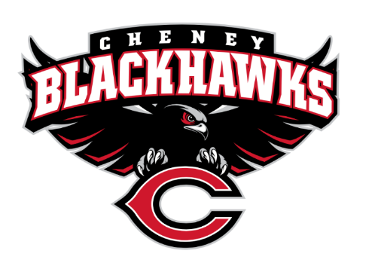
Cheney Blackhawk Booster Club
January 4, 2023
Booster Club Meeting Minutes

The Cheney Blackhawk Booster Club’s mission is to create the “Blackhawk Home Court Advantage” that inspires students, athletes, coaches, parents and the community to collectively create a positive and spirited atmosphere for all extra-curricular and athletic programs. We are volunteers who wish to serve and lead by example. We support through fundraising, stand behind strong moral character and good sportsmanship and promote a winning school spirit by encouraging attendance at all Cheney High School activities.

- Welcome & Board Intros/Krisann Hatch Meeting started at 6:30pm
  - President: Krisann Hatch
  - Vice President: Jay Evans
  - Co-Treasurers: Darcy Magalsky/Kaely Randles
  - Secretary: Kim Best
- Thank you to the following sponsors and boosters: We have our first gold sponsor! Thank you to Heritage Funeral and to Dave Ittner for securing this sponsor. We also have another member so they are now scrolling at the bottom of our website!
- Priorities Updates/Krisann Hatch
  - Establishing policies & procedures These priorities that are crossed off on the agenda, are things that we have completed and/or no longer need to be priorities.
  - Concessions’ Revenue
  - Website & Social Media Exposure
  - Establishing the role of the Parent Liaisons
  - Sponsorships/Memberships Thank you again to all of our sponsors and excited to have our first gold sponsor along with a new red/black membership! Sponsorship and membership are going to be crucial for 2023.
  - Establishing our Events Calendar We have been working on establishing our events calendar and this will be a crucial piece in the future for 2023 and beyond!
- Committee Reports
  - Concessions/Shelley Whiteley
    - Wrestling Tourney Shelley shared that this weekend is the Blackhawk invite, most all slots are filled for concession for 8-10 and 10-2. Shelley plans on being there as well and basketball players and parents to sign up. Should run pretty seamlessly. Longhorn and DAA Northwest are donating baked potatoes and chili. Menu is expanded, wrestling association is good with the menu as well.
      - Sign-ups Concession sign ups are pretty much filled but there have been cancellations and if any activities or sports wants to sign up contact Shelley and she will add you to the waitlist.
      - Baseball Concessions – tour date January 27th @ 9am Tentatively Jan 27th after the board meeting to go through and do a punch list of things in the concessions stand area.
    - Concessions Committee for the 2023-24 school year The Board has someone in mind for this and will be talking with a few folks in regards to taking over this committee.
  - Social Media/Communications/Krisann Hatch Sponsorships and additional membership milestones through social media. If you have any feedback or ideas on facebook or Instagram please feel free to reach out!
  - Sponsorships/Dave Ittner $10k in sponsorships, slow start, reaching out after the new year. If you know of some business to reach out to please let Dave know so we can make sure his team has not already reached out.
  - Distribution of brochures Tri-fold flyers are ready to go. If you have a business in mind please reach out to Dave to make sure we have not already reached out to them. Booster member flyer is now ready to go! Membership and sponsorship are through now until the end of 2024 if you sign up now. Huge extra benefit for becoming a sponsor or member!
  - Merchandise/Teresa McCorkel Teresa McCorkel to be the Merchandise Chair, Jay will still work with Teresa on this.
    - Merchandise Committee May need one other person to help out on the committee.
    - Inventory completed/placing another order Inventory is getting low, we had added merchandise, key chains, stickers, blankets, mugs, water bottles. Teresa is meeting with Jay this weekend to do some more merchandise info. We are also looking into pom poms, face tattoos, and car decals.
  - Events/Krisann Annual calendar of events. Jay came up with an idea of Bowl-A-Thon in Feb 2024. Golf Tournament tentative date of May 21st and possibly at Fairways, trying to keep it local. Tim has asked to get more involved in the Rodeo parade. Have a presence in the rodeo selling concessions and merchandise. August looking at an all sports BBQ event August 15th. Below is a list of events we are working on.
January: Blackhawk Invite Wrestling Tournament
February: Bowl-A-Thon: This will be a new CBBC event and will first occur in 2024
April: VanKuren Track Invite – booth/concessions
May: Mayfest – booth, concessions
May: Golf Tourney
July: Rodeo – booth/concessions, parade
August: BBQ associated with Sports’ Night; August 15th (tentatively), Mary Shay Soccer event August 30th
October: Battle in the 509 – booth/concessions
Sept/Oct: Homecoming added to the list of events.
November: Turkey Trot – booth/concessions (unless DECA)
December: Craft Fair – booth

g. Treasurer’s Report/Kaely Randles & Darcy Magalsky $16, 121 in the account, $4,000 holding for clubs and $2-2,500k for tennis grant/new shed.

- Grant Requests & Allocated Funds’ Request
  - None at this time None at this time.
- Good of the Order
  - Senior Banners Update Banners are up and they look great! A huge thank you to Bridget Mayfield, Tim Kennedy and the team for designing and printing. Booster club funds all senior banners!
  - Next Meeting: February 6, 2023, 6:30pm, CHS Commons (returning to Mondays) You do not need to be a member of the Booster Club to attend the meeting. Anyone can attend! Meeting adjourned at 7pm

