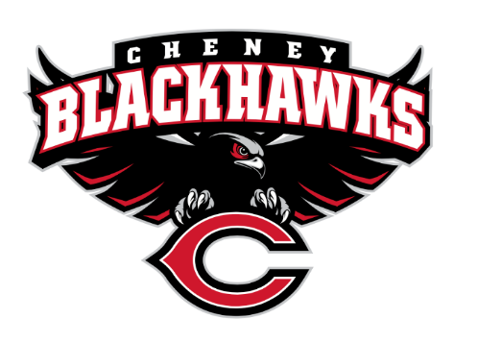
Cheney Blackhawk Booster Club
February 6, 2023
Booster Club Meeting Agenda

The Cheney Blackhawk Booster Club’s mission is to create the “Blackhawk Home Court Advantage” that inspires students, athletes, coaches, parents and the community to collectively create a positive and spirited atmosphere for all extra-curricular and athletic programs. We are volunteers who wish to serve and lead by example. We support through fundraising, stand behind strong moral character and good sportsmanship and promote a winning school spirit by encouraging attendance at all Cheney High School activities.

- Welcome & Board Intros/Krisann Hatch
  - President: Krisann Hatch
  - Vice President: Jay Evans
  - Co-Treasurers: Darcy Magalsky/Kaely Randles
  - Secretary: Kim Best
- Thank you to the following sponsors and boosters:
  - Ray & Amy Schmitt, Gold Hawk Boosters
- 2023/24 Priorities Updates/Krisann Hatch
  - Memberships
  - Sponsorships
  - Establishing our Events Calendar
- Committee Reports
  - Concessions/Shelley Whiteley
    - Baseball Concessions Update
      - Need to schedule a work day mid-February to get it operational
      - Kim to help coordinate baseball parents
    - Concessions Committee for the 2023-24 school year
      - Amanda Godsil/Erin Lutermoser
  - Social Media/Communications/Krisann Hatch
    - New “Teams” section on website
  - Sponsorships/Dave Ittner
    - Small sub-committee meeting to discuss details of sponsorships (how to…..signage, programs, etc.)
    - Discussion: Sport-specific sponsorships
  - Memberships/Krisann
    - Membership Drive/Action Plan
    - Proposed new levels
  - Merchandise/Teresa McCorkel
    - Placed order for window decals, pom-poms and face tattoos
  - Events/Krisann
    - January: Blackhawk Wrestling Invite
    - February (2024): Annual Bowl-A-Thon
    - April: VanKuren Track Invite – April 15th
    - May: Mayfest/Golf Tourney (May 21st)
    - July: Rodeo
    - August: All-Sport BBQ Kick-off/Mary Shay Soccer Tournament
    - September/October: Homecoming
    - October: Battle in the 509 Cross Country Track Meet
    - Turkey Trot
    - Craft Fair
  - Treasurer’s Report/Kaely Randles & Darcy Magalsky
- Grant Requests & Allocated Funds’ Request
  - Grants Approved:
    - Wisswell/Band: $320.28 – binders for all bands
    - Galm/Boys Soccer: $200 – balls/training sessions
    - Beamer/Baseball: $871.09 – baseballs
    - Hatch/Basketball: $75 – Senior Night flowers
    - TOTAL: = $1,391.37
  - Allocations:
    - 2/6/23 – CHS Choir requested $200 to pay their Worlds Finest Chocolates’ invoice.
    - 2/6/23 – SAN requested $400 for their Krispy Kreme fundraiser.
- Good of the Order
  - Next Meeting: March 6, 2023, 6pm, CHS Commons
  - RAFFLES

