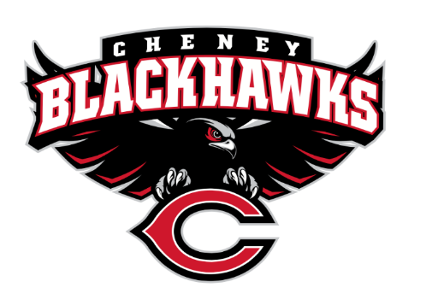
Cheney Blackhawk Booster Club
March 6, 2023
Booster Club Meeting Agenda

The Cheney Blackhawk Booster Club’s mission is to create the “Blackhawk Home Court Advantage” that inspires students, athletes, coaches, parents and the community to collectively create a positive and spirited atmosphere for all extra-curricular and athletic programs. We are volunteers who wish to serve and lead by example. We support through fundraising, stand behind strong moral character and good sportsmanship and promote a winning school spirit by encouraging attendance at all Cheney High School activities.

- Welcome & Board Intros/Krisann Hatch
  - President: Krisann Hatch
  - Vice President: Jay Evans
  - Co-Treasurers: Darcy Magalsky/Kaely Randles
  - Secretary: Kim Best
- Thank you to the following sponsors and boosters:
  - Casey & Nikki Kinzer – Gold Hawk Members
- 2023/24 Priorities Updates/Krisann Hatch
  - Memberships
  - Sponsorships
  - Establishing our Events Calendar
  - Eliminate the need for teams to seek individual sponsorships - $50,000 goal
- Committee Reports
  - Concessions/Shelley Whiteley
    - Thank you to everyone for stepping up for the Regionals’ Basketball event; HUGE success – early $7k in revenue
    - Baseball Concessions Update
      - Thank you to everyone that came out and helped with the clean up
      - Plumbing work completed today
    - Spring Concessions Sign-Ups
  - Social Media/Communications/Krisann Hatch
  - Sponsorships/Jay Evans & Kelley Collins
    - Result of sub-committee discussions
    - Revisions
  - Memberships/Krisann
    - Membership Drive/Action Plan
    - Final new levels
  - Merchandise/Jay Evans & Teresa McCorkel
    - Ordering golf items for tourney
  - Events/Krisann
    - January: Blackhawk Wrestling Invite
    - February (2024): Annual Bowl-A-Thon
    - April: VanKuren Track Invite – April 15th
    - May:
      - Mayfest May 12-13th
      - Golf Tourney – May 21st
    - June: All-Sport Recognition Night – June 5th
    - July: Rodeo
    - August: All-Sport BBQ Kick-off/Mary Shay Soccer Tournament
    - September/October: Homecoming
    - October: Battle in the 509 Cross Country Track Meet
    - Turkey Trot
    - Craft Fair
  - Treasurer’s Report/Kaely Randles & Darcy Magalsky
- Grant Requests & Allocated Funds’ Request
  - Grants Approved:
    - HOSA/Collins: $1500 – 15 kids to attend Leadership Conference
    - Currently reviewing: Football - $12,900 for 2 sets of uniforms
  - Allocations:
    - 2/17 – Cheer - $180 – State for two cheerleaders and memberships for two assistant coaches
- Good of the Order
  - Received our new CBBC shade tent
  - Next Meeting: April 10, 2023, 6pm, CHS Commons
  - RAFFLES

