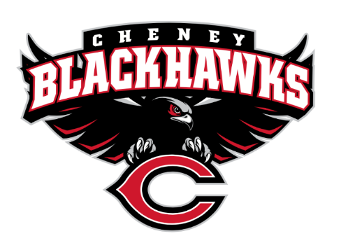
Cheney Blackhawk Booster Club
May 8, 2023
Booster Club Meeting Agenda

The Cheney Blackhawk Booster Club’s mission is to create the “Blackhawk Home Court Advantage” that inspires students, athletes, coaches, parents and the community to collectively create a positive and spirited atmosphere for all extra-curricular and athletic programs. We are volunteers who wish to serve and lead by example. We support through fundraising, stand behind strong moral character and good sportsmanship and promote a winning school spirit by encouraging attendance at all Cheney High School activities.

- Welcome & Board Intros/Krisann Hatch
  - President: Krisann Hatch
  - Vice President: Jay Evans
  - Co-Treasurers: Darcy Magalsky/Kaely Randles
  - Secretary: Kim Best
- Thank you to the following sponsors and boosters:
  - New Member – Erin Marini and Family
- 2023/24 Priorities Updates/Krisann Hatch
  - Memberships
  - Sponsorships
  - Establishing our Events Calendar
  - Eliminate the need for teams to seek individual sponsorships - $50,000 goal
- Committee Reports
  - Concessions/Shelley Whiteley
    - Spring Update
    - Post Season?
    - Pepsi Distributor Update
  - Social Media/Communications/Krisann Hatch
  - Sponsorships/Jay Evans & Kelly Collins
    - Update
  - Memberships/Krisann
    - Membership Drive/Action Plan
    - Have all exclusive membership items
  - Merchandise/Jay Evans & Teresa McCorkel
    - Will be placing order soon for Fall
    - Sold $1153 at the Incoming Freshman Orientation
    - Upcoming events:
      - May 13th – Mayfest
      - May 21st – Golf Tourney
  - Events/Krisann
    - January: Blackhawk Wrestling Invite
    - February (2024): Annual Bowl-A-Thon
    - April: VanKuren Track Invite – April 15th
    - May:
      - Mayfest May 13th
      - Golf Tourney – May 21st
    - June: All-Sport Recognition Night – June 5th
    - July: Rodeo
    - August: All-Sport BBQ Kick-off/Mary Shay Soccer Tournament
    - September/October: Homecoming
    - October: Battle in the 509 Cross Country Track Meet
    - Turkey Trot
    - Craft Fair
  - Treasurer’s Report/Kaely Randles & Darcy Magalsky
- Grant Requests & Allocated Funds’ Request
  - Grants Approved:
    - Football: Uniforms - $6,400; approved but don’t need to pay until September
    - FBLA: Received an individual request, but considering one grant for all 15 going to Nationals
  - Allocations:
- Good of the Order
  - Next Meeting: June 5, 2023, 6pm, All-Sport Recognition Night!

