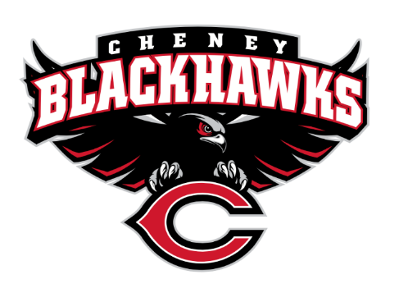
Cheney Blackhawk Booster Club
May 8, 2023
Booster Club Meeting MINUTES

The Cheney Blackhawk Booster Club’s mission is to create the “Blackhawk Home Court Advantage” that inspires students, athletes, coaches, parents and the community to collectively create a positive and spirited atmosphere for all extra-curricular and athletic programs. We are volunteers who wish to serve and lead by example. We support through fundraising, stand behind strong moral character and good sportsmanship and promote a winning school spirit by encouraging attendance at all Cheney High School activities.

- Welcome & Board Intros/Krisann Hatch
  - President: Krisann Hatch
  - Vice President: Jay Evans
  - Co-Treasurers: Darcy Magalsky/Kaely Randles
  - Secretary: Kim Best
- Thank you to the following sponsors and boosters:
  - New Member – Erin Marini and Family
- 2023/24 Priorities Updates/Krisann Hatch
  - Memberships
  - Sponsorships
  - Establishing our Events Calendar
  - Eliminate the need for teams to seek individual sponsorships - $50,000 goal
- Committee Reports
  - Concessions/Shelley Whiteley
    - Spring Update – all going well – just no sales; still have the two CMS events – track on 15th and baseball on the 23rd
    - Post Season?
      - Not hosting any post season play
      - We do still have PowderPuff & BuffPuff – SAN handling both
    - Pepsi Distributor Update
      - Met with Dan Liebhardt, Pepsi Distributor, on May 1st; will be getting all beverages delivered to the high school; will be getting some new equipment and getting two menu signs
    - Do we want to donate leftover concessions items to the SAN event? Board to discuss
  - Social Media/Communications/Krisann Hatch
  - Sponsorships/Jay Evans & Kelly Collins
    - Update – team met last week and are splitting up the area geographically; Kelly has Cheney; John & Jay have A-Heights; Katie has Latah area
  - Memberships/Krisann & Kim C.
    - Membership Drive/Action Plan; Krisann & Kim meeting soon to review membership list and outstanding membership packets in preparation for August event; also need to send renewal notices to 2022/23 members
    - Have all exclusive membership items
  - Merchandise/Jay Evans & Teresa McCorkel
    - Will be placing order soon for Fall
    - Sold $1153 at the Incoming Freshman Orientation
    - Upcoming events:
      - May 13th – Mayfest – sign-up genius is available and nearly full
      - May 21st – Golf Tourney
  - Events/Krisann
    - January: Blackhawk Wrestling Invite
    - February (2024): Annual Bowl-A-Thon
    - April: VanKuren Track Invite – April 15th
    - May:
      - Mayfest May 13th
      - Golf Tourney – May 21st
        - All good; did have two teams drop out so currently has two full teams available to fill;
        - Thank you to new major sponsor Collins Family Dentistry
        - Do need more silent auction items; thank you to Coach Byrd for making cornhole boards and thank you to Coach Beamer for donating Seahawks tickets most teams are paid up but will be collecting some fees on the day of event; need spirit gear set up by 8am and to remain through BBQ; likely done around 1pm
    - June: All-Sport Recognition Night – June 5th
    - July: Rodeo
    - August: All-Sport BBQ Kick-off/Mary Shay Soccer Tournament
    - September/October: Homecoming
    - October: Battle in the 509 Cross Country Track Meet
    - Turkey Trot
    - Craft Fair
  - Treasurer’s Report/Kaely Randles & Darcy Magalsky
    - Current bank balance = $43796
    - Current allocated funds = $22403
- Grant Requests & Allocated Funds’ Request
  - Grants Approved:
    - Football: Uniforms - $6,400; approved but don’t need to pay until September
    - FBLA: Received an individual request, but considering one grant for all 15 going to Nationals;UPDATE – Board approved $500 for FBLA; Darcy to coordinate with Adam Smith
  - Allocations:
- Good of the Order
  - Senior Banners – will Bridget still be doing next year? Also, Whipple is moving to middle school so need to find out who can do the banners at CHS; UPDATE: Krisann confirmed that Bridget will do the senior banners for the 2023/24
  - Coach Ryan – girls’ locker room hallway project; has everything ready to go; estimates will need less than $2k to complete project; requested he submit a grant request ASAP
  - Next Meeting: June 5, 2023, 6pm, All-Sport Recognition Night!

