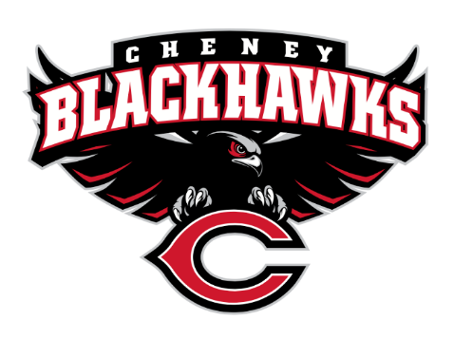
Cheney Blackhawk Booster Club
November 8, 2023
Booster Club Meeting Agenda

The Cheney Blackhawk Booster Club’s mission is to create the “Blackhawk Home Court Advantage” that inspires students, athletes, coaches, parents and the community to collectively create a positive and spirited atmosphere for all extra-curricular and athletic programs. We are volunteers who wish to serve and lead by example. We support through fundraising, stand behind strong moral character and good sportsmanship and promote a winning school spirit by encouraging attendance at all Cheney High School activities.

- Welcome & Board Intros/Krisann Hatch
  - President: Krisann Hatch
  - Vice President: Jay Evans
  - Co-Treasurers: Darcy Magalsky/Kaely Randles
  - Secretary: Kim Best
- Thank you to all of our sponsors and boosters!
  - 11 Sponsors, plus PowerAd sponsors
  - 31 Members
- 2023/24 Priorities Updates/Krisann Hatch
  - Memberships
  - Sponsorships
  - Revenue Generation through Concessions & Spirit Gear Sales
  - Establishing our Events Calendar
- Committee Reports
  - Concessions/Erin Luttermoser & Amanda Godsil
    - Fall Summary
    - Winter Update
      - Winter Sign-up Genius?
  - Social Media/Communications/Krisann Hatch & Kim Best
    - New posting policy
  - Sponsorships/Jay Evans & Kelly Collins
    - Update
    - In the works: OK Electric, Air Force, J&M Fabrication, Maverik, Owl Pharmacy, Cottonwood Creek, Mtn View Sprinklers, Sullivan Family Farms
    - Current offer – wait until Jan 2024 – 6 months free!
  - Memberships/Krisann Hatch & Kim Cunningham
    - Fall Update
    - 31members AND COUNTING!
    - $25 CHS Staff Membership; will provide a 25% off coupon for Spirit Gear item
    - Same membership offer – sign up after Jan 1 and get 6 months free – through June 2025
  - Merchandise/Teresa McCorkel & Cassie Bleam
    - Fall Update?
    - Online store OPEN
    - Adding some new items and prepping for Craft Fair
      - Stanley dupe tumbler
      - Joggers
      - Zip-up hoodie
      - Belt bag – Lululemon dupe
  - Events/Krisann
    - January: Blackhawk Wrestling Invite
    - February (2024): Annual Bowl-A-Thon; confirming a date and will be looking to form a committee
    - April: VanKuren Track Invite
    - May:
      - Mayfest
      - Golf Tourney
    - June: All-Sport Recognition Night
    - July: Rodeo
    - August:
      - All-Sport BBQ Kick-off
      - Mary Shay Soccer Tournament
    - September:
      - Band Community Day
      - Battle in the 509 Cross Country Track
    - October: Homecoming
    - November: Turkey Trot – November 23rd
    - Craft Fair – December 2nd
  - Treasurer’s Report/Kaely Randles & Darcy Magalsky
- Grant Requests
  - Girls’ Volleyball - $174 for Senior Night flowers
- Good of the Order
  - Ken Ryan:
    - Hall of Fame/Wing of Excellence
    - Media Day – November 18th
    - Other?
  - Next Meeting: December 6, 2023, 6pm, CHS Commons

