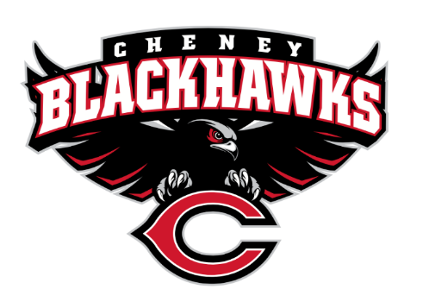
Cheney Blackhawk Booster Club
January 3, 2024
Booster Club Meeting Agenda

The Cheney Blackhawk Booster Club’s mission is to create the “Blackhawk Home Court Advantage” that inspires students, athletes, coaches, parents and the community to collectively create a positive and spirited atmosphere for all extra-curricular and athletic programs. We are volunteers who wish to serve and lead by example. We support through fundraising, stand behind strong moral character and good sportsmanship and promote a winning school spirit by encouraging attendance at all Cheney High School activities.

- Welcome & Board Intros/Krisann Hatch
  - President: Krisann Hatch
  - Vice President: Jay Evans
  - Co-Treasurers: Darcy Magalsky/Kaely Randles
  - Secretary: Kim Best
- Thank you to all of our sponsors and boosters!
  - 11 Sponsors, plus PowerAd sponsors
  - 34 Members
- 2023/24 Priorities Updates/Krisann Hatch
  - Memberships
  - Sponsorships
  - Revenue Generation through Concessions & Spirit Gear Sales
  - Establishing our Events Calendar
- Committee Reports
  - Concessions/Erin Luttermoser
    - Winter Update
      - Blackhawk Wrestling Invite – 1/6/24; 7am-7pm for Concessions
      - Band event on January 27th
  - Social Media/Communications/Kim Best
  - Sponsorships/OPEN
    - Update
  - Memberships/Jenny Gasperino
    - Winter Update
    - 34 members AND COUNTING!
  - Merchandise/Cassie Bleam
    - Winter Update
  - Events/Krisann
    - January: Blackhawk Wrestling Invite – January 6th
    - March – Spring Sports’ Media Day -
    - April: VanKuren Track Invite
    - May:
      - Mayfest
      - Golf Tourney
      - May 31st – Middle School Soccer at Westwood
    - June:
      - All-Sport Recognition Night
      - June 1-2 – 3v3 Soccer Tournament
    - July: Rodeo
    - August:
      - All-Sport BBQ Kick-off
      - Mary Shay Soccer Tournament
    - September:
      - Band Community Day
      - Battle in the 509 Cross Country Track
    - October: Homecoming
    - November: Turkey Trot
    - Craft Fair
  - Treasurer’s Report/Kaely Randles & Darcy Magalsky
- Grant Requests
  - Band; requested $12,278 for 7 assistants and staff to attend the Bands of America Grand National Championships in Indianapolis in November 2024; approved $6100 towards this total.
  - Boys Golf; requested $4994.51 for uniforms, golf bags, and early training using simulators; after much discussion, Ken committed to providing the polos, Justin had indicated they had a $1000 sponsor towards the bags, so we approved $3,450 towards the request
- Good of the Order
  - Ken Ryan:
  - Next Meeting: February 7, 2024, 6pm, CHS Commons

