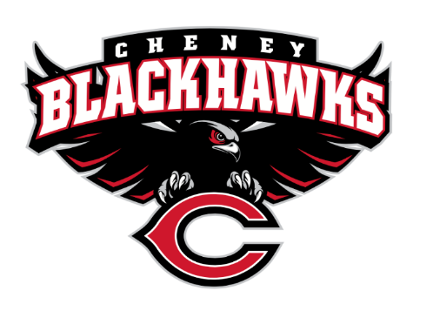
Cheney Blackhawk Booster Club
March 6, 2024
Booster Club Meeting Agenda

The Cheney Blackhawk Booster Club’s mission is to create the “Blackhawk Home Court Advantage” that inspires students, athletes, coaches, parents and the community to collectively create a positive and spirited atmosphere for all extra-curricular and athletic programs. We are volunteers who wish to serve and lead by example. We support through fundraising, stand behind strong moral character and good sportsmanship and promote a winning school spirit by encouraging attendance at all Cheney High School activities.

- Welcome & Board Intros/Krisann Hatch
  - President: Krisann Hatch
  - Vice President: Jay Evans (OPEN POSITION)
  - Co-Treasurers: Darcy Magalsky/Kaely Randles
  - Secretary: Kim Best
- Board Updates
  - Vice President- OPEN
  - Secretary – CHANGES
  - Concessions Chair/Concessions Committee
- Thank you to all of our sponsors and boosters!
  - 11 Sponsors, plus PowerAd sponsors
  - 37 Members
- 2023/24 Priorities Updates/Krisann Hatch
  - Memberships
  - Sponsorships
  - Revenue Generation through Concessions & Spirit Gear Sales
  - Establishing our Events Calendar
- Committee Reports
  - Concessions/Erin Luttermoser
    - Spring Update
    - VanKuren Invite, April 13th – Sign-ups?
    - April 25th – FAA Bingo Night
  - Social Media/Communications/Kim Best
  - Sponsorships/OPEN
    - Update
  - Memberships/Jenny Gasperino
    - Update
    - 37 members AND COUNTING!
  - Merchandise/Cassie Bleam
    - Update
  - Events/Krisann
    - January:
      - Blackhawk Wrestling Invite
      - Band Competition event
    - March – Spring Sports’ Media Day
    - April:
      - April 13, 2024; VanKuren Track Invite
    - May:
      - Mayfest – May 10-11, 2024
      - Golf Tourney Update
        - Flyer distribution
      - May 31st – Middle School Soccer at Westwood
    - June:
      - All-Sport Recognition Night
      - June 1-2 – 3v3 Soccer Tournament
    - July: Rodeo – July 12-14th
    - August:
      - All-Sport BBQ Kick-off – August 24, 2024
      - Mary Shay Soccer Tournament
    - September:
      - Band Community Day
      - Battle in the 509 Cross Country Track
    - October: Homecoming
    - November: Turkey Trot
    - Craft Fair
  - Treasurer’s Report/Kaely Randles & Darcy Magalsky
- Grant Requests
  - Chess Club; requested $750.05 for entry fee, lodging and fuel to take 6 students to compete in state; APPROVED
- Good of the Order
  - Ken Ryan:
    - THE LETTER ARE UP!
  - Next Meeting: April 10, 2024, 6pm, CHS Library

